Full Mesh

What Is Full Mesh?
# Source: Chatgpt (GPT‑5 Mini) at [12/18/2025]
A Full Mesh Topology is a type of network layout where every device is directly connected to every other device in the network. It offers the highest level of redundancy, reliability, and fault tolerance.

🧠 Simple Definition:
# Source: Chatgpt (GPT‑5 Mini) at [12/18/2025]
In a Full Mesh, all nodes are interconnected. If there are n devices, each one has n - 1 direct links, resulting in n(n - 1)/2 total connections.

🖼️ Visual Example (4 Devices):
# Source: Chatgpt (GPT‑5 Mini) at [12/18/2025]
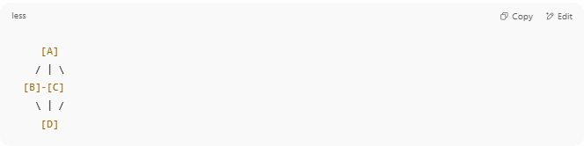
[A]
/ | \
[B]-[C]
\ | /
[D]

Each device can communicate with every other device without relying on any intermediate node.

🔁 How It Works
# Source: Chatgpt (GPT‑5 Mini) at [12/18/2025]
- No central switch or router is required for communication.
- If one link or node fails, data can take alternative direct paths.
- Routing decisions can be made dynamically for optimal paths.

✅ Advantages
# Source: Chatgpt (GPT‑5 Mini) at [12/18/2025]
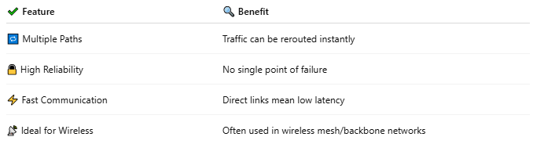
✔ Feature | 🔍 Benefit
🔁 Multiple Paths | Traffic can be rerouted instantly
🔒 High Reliability | No single point of failure
⚡ Fast Communication | Direct links mean low latency
📡 Ideal for Wireless | Often used in wireless mesh/backbone networks

❌ Disadvantages
# Source: Chatgpt (GPT‑5 Mini) at [12/18/2025]
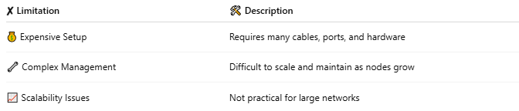
✘ Limitation | 🛠 Description
💰 Expensive Setup | Requires many cables, ports, and hardware
🔧 Complex Management | Difficult to scale and maintain as nodes grow
📈 Scalability Issues | Not practical for large networks

📊 Connection Formula
# Source: Chatgpt (GPT‑5 Mini) at [12/18/2025]
For n devices:
Total Connections = n(n - 1) / 2
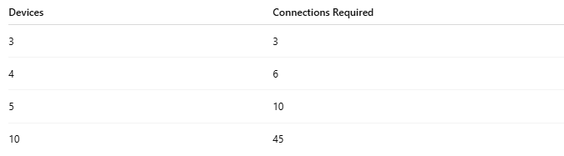
Devices | Connections Required
3 | 3
4 | 6
5 | 10
10 | 45

🛠 Use Cases
# Source: Chatgpt (GPT‑5 Mini) at [12/18/2025]
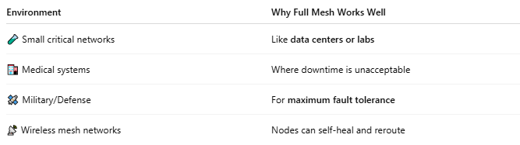
Environment | Why Full Mesh Works Well
🧪 Small critical networks | Like data centers or labs
🏥 Medical systems | Where downtime is unacceptable
🛰️ Military/Defense | For maximum fault tolerance
📡 Wireless mesh networks | Nodes can self-heal and reroute

✅ Summary
# Source: Chatgpt (GPT‑5 Mini) at [12/18/2025]
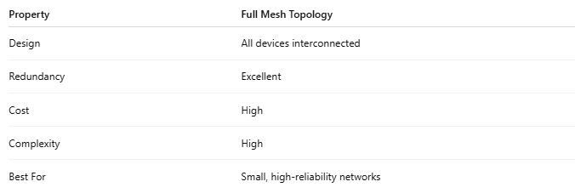
Property | Full Mesh Topology
Design | All devices interconnected
Redundancy | Excellent
Cost | High
Complexity | High
Best For | Small, high-reliability networks

